**Weekly Submission 4**

**Name: Dariush Ahrari Personal code: 10723063**

**1.**

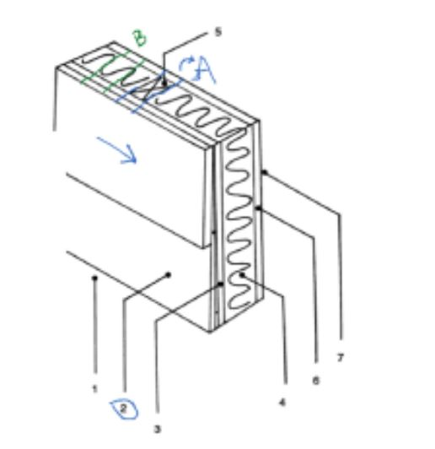

**Section A : Section with wood**

**Section B : Section with insulation**

|  |  |  |
| --- | --- | --- |
|  | Wood (m2·℃/W) | Insulation (m2·℃/W) |
| Outside air | 0.03 | 0.03 |
| Wood bevel 1 | 0.14 | 0.14 |
| Plywood (13mm ) | 0.11 | 0.11 |
| Urethane rigif foam | NO | 0.98*90/25=3.528 |
| Wood studs | 0.63 | NO |
| Gypsum board | 0.079 | 0.079 |
| Inside surface | 0.12 | 0.12 |

R’withWood = 0.03+0.14+0.11+0.63+0.079+0.12 = 1.109 m2·℃/W

R’withIns = 0.03+0.14+0.11+3.528+0.079+0.12 = 4.007 m2·℃/W

Uwood== = 0.9017 W/m2·℃

Uins== = 0.2496 W/m2·℃

= +

R’=R*A → R=

= + → = +

From the presentation I know that, $\frac{1}{R'}$ = U

Utot*Atot= Uwood*Awood + Uins*Ains

= 0.9017*25%+0.2496*75% = 0.4126 W/m2·℃

From the definition of U,

$${\dot{Q}}_{tot}=U_{tot }*A_{tot }*ΔT$$

= 0.4126*[(50*2.5)*(1-20%)]*[22-(-2)]

= 990.24 W

**2. A summary of what I have learnt in this session about radiation and radiative heat transfer.**

Thermal radiation is the emission of electromagnetic waves from all matter that has a temperature greater than absolute zero, it is due to the heat of the material, the characteristics of which depend on its temperature. The type of electromagnetic radiation that is pertinent to heat transfer is the thermal radiation emitted as a result of energy transitions of molecules, atoms, and electrons of a substance. That explains the temperature in the physical field: temperature is a measure of the strength of these activities at the microscopic level, and the rate of thermal radiation emission increases with increasing temperature.

Absolute zero is an idealized physical condition, thermal radiation happens almost in all objects, regardless of the material form of the object, (solid, liquid or gas), all the surrounding objects will basically radiate heat to the surroundings.

A significant difference between thermal radiation and other mechanisms of heat transfer is, thermal radiation does not need the presence of a material medium to take place. So thermal radiation can occur in vacuum.

Electromagnetic radiation is a propagation of a collection of discrete packets of energy called photons. Thermal radiation is an electromagnetic wave, it is characterized by its frequency and wavelength. The wavelength is proportional to the propagation speed and inversely proportional to the frequency. This relationship is given by the following equation:

**λ= $\frac{c}{v}$** (c is speed of propagation of a wave, v is frequency), wavelength of electromagnetic waves [micrometers (1·10-6m)]

All electromagnetic waves, including thermal radiation, regardless of wavelength or frequency, travels at the speed of light.

The thermal radiation is continually emitted from every part of the surface of the object that has a temperature greater than absolute zero into every direction.

Surfaces emit thermal radiation and reflect electromagnetic waves at the same time. If we assume an object that emits radiation but does not reflect any electromagnetic waves, it is a “black body”, which is an idealized body that doesn’t exist in real life. A blackbody emits the maximum amount of radiation by a surface at a given temperature, and absorbs all incident radiation, regardless of wavelength and direction.

The emitted radiation is a continuous function of wavelength. At any specified temperature, it increases with wavelength, reaches a peak, and then decreases with increasing wavelength. At any wavelength, the amount of emitted radiation increases with increasing temperature.